Introduction to Database Systems (CSD317)

**Practice Lab#3**

# Date: 14/09/22

**You have to upload the screen shot (black screen) of output with the queries one by one, in a word doc & file name must be-> Roll No_PracticeLab#3.**

Note: - Please use sniping tool to crop the query and its output.

1. Create and Display the tables department & employee (Drop both tables if already exist).

# Structure: Department Structure: Employee

|  |  |
| --- | --- |
| **Attribute Name** | **Data Declaration** |
| Dept_ID | Int, primary key |
| Location | Varchar(20) & it should be auto filed as **SNU** if we don’t want to fill any value |

|  |  |
| --- | --- |
| **Attribute Name** | **Data Declaration** |
| Emp_ID | Int, primary key, auto_increment(*Auto Increment start value=****1001)*** |
| Emp_Name | Varchar(30) & default value is **SNU Student** |
| Mgr_ID | Int |
| Dept_ID | Int |

Display both the tables after entering the data as given below (Note: - enter data into both tables exactly the same as given below & do not insert the values for Emp_ID, it will be auto filled.

**Table1: Department**

**Table 2: Employee**

|  |  |
| --- | --- |
| **Dept_ID** | **Location** |
| 200 | Washington |
| 201 | California |
| 202 |  |
| 203 | Houston |
| 204 | Washington |
| 205 |  |

|  |  |  |  |
| --- | --- | --- | --- |
| **Emp_ID** | **Name** | **Mgr_ID** | **Dept_ID** |
|  | Alex Bert | 1003 | 200 |
|  |  | 1003 | 200 |
|  | Mery Lee | Null | 200 |
|  |  | 1006 | 202 |
|  | Reyan Fert | 1006 | 202 |
|  | Luther Warn | Null | 202 |
|  | Amy | 1008 | 203 |
|  | Coogan | Null | 204 |

# Join Operations:

* 1. Display the matching record (Emp_ID, Name & Location) from both the tables.

* 1. Display the matching record (Emp_ID, Name & Location) records from both tables and all records from department table.

* 1. Display the matching record (Emp_ID, Name & Location) records from both tables and all records from employee table.

4.Display the list of employees (Emp_ID & Name) who are only managers in ascending order (this is self-join).

5.Display the cross product from both the tables.

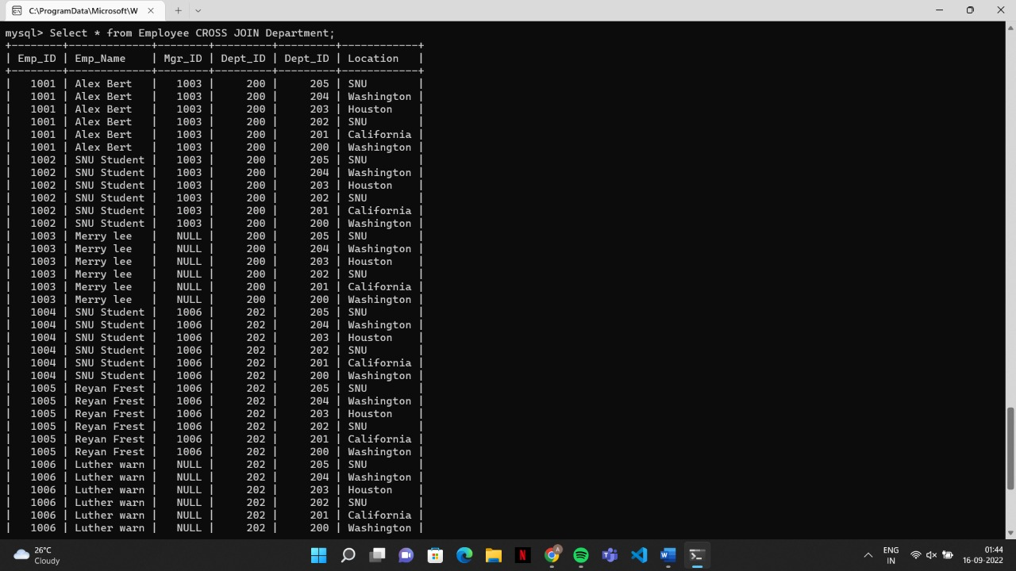

**Alter Operation’s**: - Use employee table

# Add column in the table:-

* 1. Retrieve all details of table **employee** & it’s schema after adding a new column

# Salary decimal (8, 2) not null.

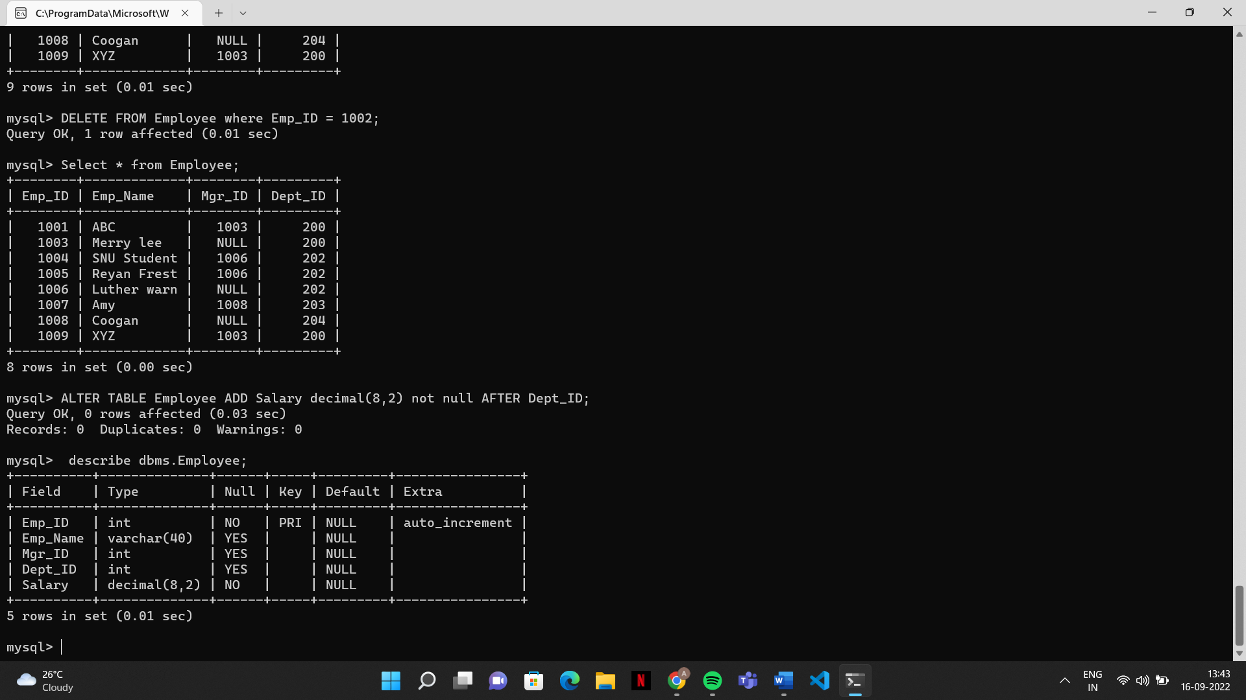

* 1. Insert one more records to **employee** table as given below:

|  |  |  |  |
| --- | --- | --- | --- |
| **Emp_Name** | **Mgr_ID** | **Dept_ID** | **Salary** |
| XYZ | 1003 | 200 | 10000.12 |

Display the table **employee** & its schema.

# Modify column size & rename column:-

Change the size of the field name as **varchar(40)**.

* 1. Display the schema of table **employee.**

* 1. Rename column **salary** to **Emp_sal decimal (10,2).**

* 1. Display the schema of table employee.

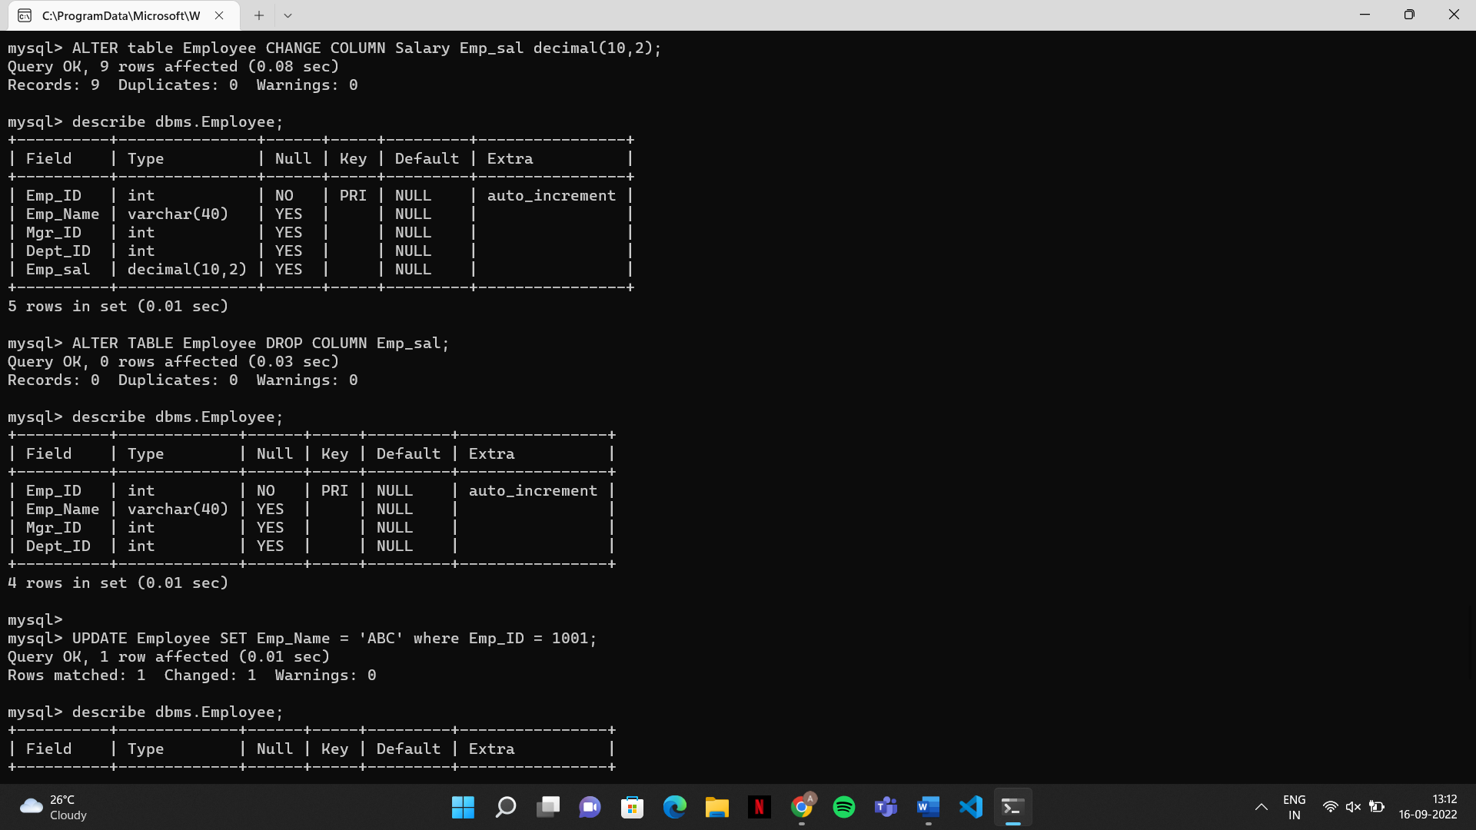

# Remove column from the table

* 1. Remove Emp_sal field from table employee.

* 1. Display the schema of table employee.

**Update Operation:-** Use employee table

1. Update name as “ABC” for emp_id = 1001

1. Display the table employee

**Delete Operation:-** Use employee table

1. Delete data for emp_id = 1002

1. Display the table employee

